* Appendix of lessons learned (10 points): Did you make any mistakes along the way? Please give examples of the mistake and show how you corrected it. I will compile these "lessons learned" so that everyone can benefit. Put these in a separate plain text document (with comments). In other words - teach your professor something about R, displaying results, or web scraping. We learn best when we teach.

The toughest part of debug is when I try to plot a pie chart.

To make the pie chart more readable, I cannot put too many groups into it, otherwise it is hard to distinguish groups due to similar color.

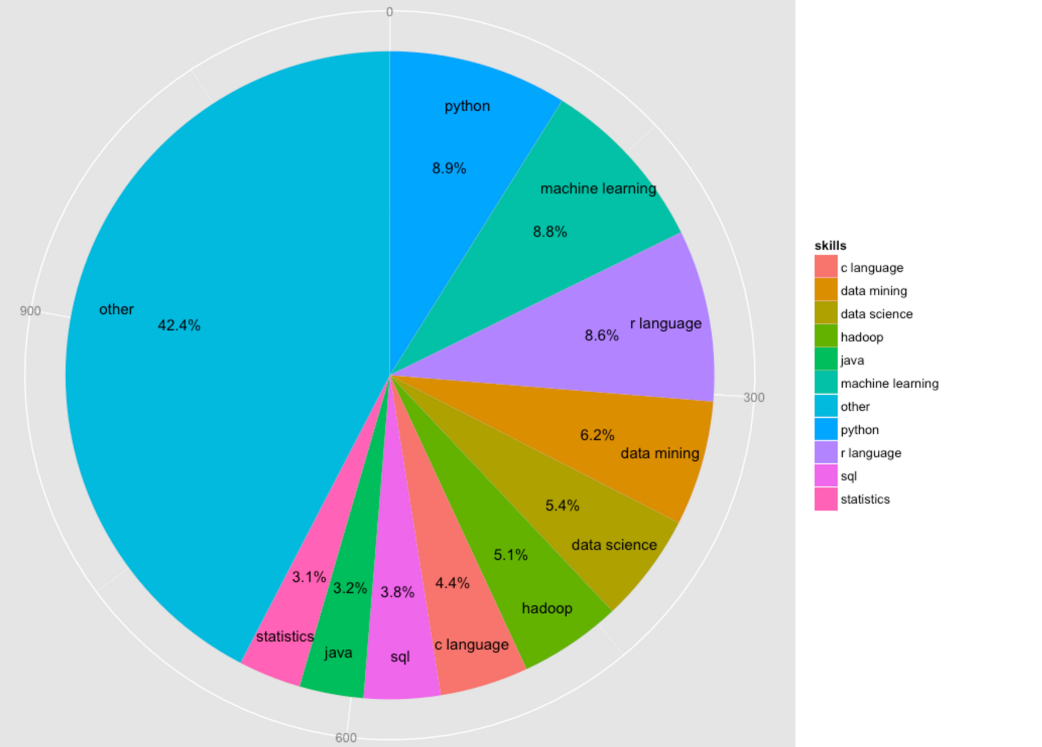

So I have to put a group called “other”. After I used the following code to create “other” group, I cannot plot the correct pie chart. The ratio(area) of “other” and other groups is incorrect. And it took me 5 hours to figure out the reason is “rbind” will change the type of skills.pc$count from numeric to character. And we of course cannot plot a correct pie chart if the number is saved as character.

skills.pc <- data.frame(skills)

names(skills.pc)<-"count"

skills.pc$skills <- attributes(skills.pc)$row.names

other.id <- NULL

other.sum <- 0

for (i in 1:dim(skills.pc$count))

{

if (skills.pc$count[i] < 30)

{

other.id <- c(other.id,i);

other.sum <- as.integer(unname(other.sum + skills.pc$count[i]))

}

}

skills.pc <- skills.pc[-other.id,]

skills.pc <- rbind.data.frame(skills.pc,c(other.sum,"other"))

skills.pc$count <- as.integer(skills.pc$count)

count.sum <- sum(skills.pc$count)